Chapter 1.Writing a Program - Viết một chương trình
1. Cho biết yêu cầu phần mềm, yêu cầu chức năng, yêu cầu phi chức năng là gì? Cho ví dụ một yêu cầu chức năng và một yêu cầu phi chức năng.
2. Trình bày ba loại yêu cầu phi chức năng tiêu biểu.
Chapter 2. Building a System – Xây dựng hệ thống
1. Define the depth versus the breadth issue in software complexity
The breadth issue addresses the sheer numbers (các con số tuyệt đối) involving the following:
- Major functions
- Features within each functional area
- Interfaces of other external systems
- Simultaneous users
- Types of data and data structures.
The depth issue addresses the linkage and the relationships among items. The linkage may either be through the sharing of data or through the transfer of control, or both. These relationships may be hierarchical, sequential, loop, recursive, or some other form.

1. Độ phức tạp của phần mềm theo chiều rộng và chiều sâu (bread and depth issues) được xác định thông qua những yếu tố nào?

2. List technical and non-technical issues in developing large systems
Technical:
Problem and solution simplification
Technology and tools choices
Process and Methodology
Non-Technical:
Project effort estimation and scheduling
Assignments and communications

2. Cho biết các vấn đề kỹ thuật và phi kỹ thuật trong phát triển các hệ thống lớn.

3. List four factors that should be considered in deciding how many post-release people will be needed?
Number of expected users and customers
Number and type of known problems that existed at release time
Projected number of problems that will be discovered by users
Amount of user training
Amount of support personnel training
Number of development personnel committed to support the system
Expected number of problem-fix releases and future functional releases.

3. Cho biết các yếu tố cần xem xét để xác định số lượng người cần có cho các công việc sau khi chuyển giao phần mềm cho khách hàng.

Chapter 3. Engineering of software – Công nghệ phần mềm
1.List key reasons that have caused both software project successes and failures
Success:
User involvement
Executive management support
Clear requirement statements
Proper planning
Failure:
Lack of user input
Incomplete requirements
Changing requirements
1. Liệt kê các nguyên nhân chính làm một dự án phần mềm thành công và thất bại.

2. From the definition of software engineering, list three areas that software engineering must touch upon
Technical and business processes
Specific methodologies and techniques
Product characterization and metrics for measurements
People skills and team work
Project coordination and management

2. Công nghệ phần mềm là gì? Liêt kê các lĩnh vực có trong công nghệ phần mềm .
3. What are the eight principles for software engineering code of ethics recommended by the IEEE-CS/ACM Version 5.2 joint task force report?
  - Software engineers shall act consistently with the public interest
  - Software engineers shall act in a manner that is in the best interest of their client and employer, consistent with the public interest
  - Software engineers shall ensure that their products and related modifications meet the highest professional standards possible
  - Software engineers shall maintain integrity and independence in their professional judgment
  - Software engineering managers and leaders shall subscribe to and promote an ethical approach to the management of software development and maintenance
  - Software engineers shall advance the integrity and reputation of the profession consistent with the public interest
  - Software engineers shall be fair to and supportive of their colleagues
  - Software engineers shall participate in lifelong learning regarding the practice of their profession and shall promote an ethical approach to the practice of the profession.
3. Cho biết tám nguyên lý về đạo đức nghề nghiệp trong công nghệ phần mềm của IEEE-CS và ACM.
4. List Davis’s Early 15 principles
Make quality number 1
High quality software is possible
Give products to customers early
Determine the problem before writing the requirements
Evaluate design alternatives
Use an appropriate process model
Use different languages for different phases
Minimize intellectual distances
Put techniques before tools
Get it right before you make it faster
Inspect code
Good management is more important than good technology
People are the key to success
Follow with care
Take responsibility
4. Cho biết 15 nguyên tắc xây dựng phần mềm của Davis.
Chapter 4. Software Process Models – Các mô hình tiến trình phần mềm
1. Discuss one advantage and one disadvantage of the waterfall process

Advantages of Waterfall Iterative Model
1) Waterfall model is simple to implement and also the amount of resources required for it are minimal.
2) In this model, output is generated after each stage (as seen before), therefore it has high visibility. The client and project manager gets a feel that there is considerable progress. Here it is important to note that in any project psychological factors also play an important role.
3) Project management, both at internal level and client's level, is easy again because of visible outputs after each phase. Deadlines can be set for the completion of each phase and evaluation can be done from time to time, to check if project is going as per milestones.
4) This methodology is significantly better than the haphazard approach to develop software. It provides a template into which methods of analysis, design, coding, testing and maintenance can be placed.
5) This methodology is preferred in projects where quality is more important as compared to schedule or cost.

Disadvantages of Waterfall Iterative Model of SDLC
1) Real projects rarely follow the sequential flow and iterations in this model are handled indirectly. These changes can cause confusion as the project proceeds.
2) It is often difficult to get customer requirements explicitly. Thus specifications can't be freezed. If that case arises baseline approach is followed, wherein output of one phase is carried forward to next phase. For example, even if SRS is not well defined and requirements can't be freezed, still design starts. Now if any changes are made in SRS then formal procedure is followed to put those changes in baseline document.
3) In this model we freeze software and hardware. But as technology changes at a rapid pace,such freezing is not advisable especially in long-term projects.
4) This method is especially bad in case client is not IT-literate as getting specifications from such a person is tough.
5) Even a small change in any previous stage can cause big problem for subsequent phases as all phases are dependent on each-other.
6) Going back a phase or two can be a costly affair.

Projects where Waterfall Method is suitable for SDLC:-
1) In development of database-related software, eg commercial projects.
2) In development of E-commerce website or portal.
3) In Development of network protocol software.
1. Vẽ biểu đồ minh họa và giải thích các hoạt động cho mô hình tiến trình phát triển phần mềm thác nước (waterfall model).

2. Vẽ biểu đồ minh họa và giải thích mô hình tiến trình phát triển phần mềm xoắn ốc (spiral model).

2.What are the four quadrants in a spiral model? Trace the requirements set of activities through each quadrant.
Identify the objectives, alternatives, or constraints for each cycle of the spiral.
Evaluate the alternatives relative to the objectives and constraints. In performing this step, many of the risks are identified and evaluated.
Depending on the amount of and type of identidied risks, develop a prototype, more detailed evaluation, an evolutionary development, or some other step to further reduce risk of achieving the identified objective. On the other hand, if the risk is substantially reduced, the next step may just be a task such as requirements, design, or code.
Validate the achievement of the objective and plan for the next cycle.

3. List all of the key processes addressed by SEI’s CMM model. Which ones are required for maturity level 2?

- Software Engineering Institute (SEI) proposed a Capability Maturity Model (CMM) to help software organizations assess their maturity and provide guidance in software development.
  - Initial : there is no process and any success is by luck or with a special person.
  - Repeatable: has mastered 6 processes and can repeat its success with these 6 processes: 1) requirements mgmt, 2)project tracking, 3)quality assurance, 4)project planning, 5)subcontract mgmt, and 6)configuration management
  - Defined: has mastered 7 more processes and is competent at software construction: 1) organization process, 2) training program, 3) product engineering, 4) peer review, 5) organization process definition, 6) integrated soft. mgmt, and 7) inter-group coordination
  - Managed: has introduced 2 more processes that deal with quantitative measurement and quality: 1) quantitative process management and 2) quality mgmt
  - Optimizing: reaching this highest level requires the mastering of continuous improvement with 3 more processes: 1)defect prevention, 2) technology change management, 3) process change management
3. Trình bày mô hình trưởng thành về năng lực (Capability Maturity Model - CMM) do SEI (Software Engineering Institute) đề xuất.
4. How many process areas, in total, are included in SEI’s Software CMMI? List those that fall into the engineering category and the support category
In 2001, CMM was upgraded to CMMI (CMM Integrated).
- There are 25 processes covering 4 major categories :
  - Process Management (has 5 processes):
    - Organization process focus
    - Organizational process definition
    - Organizational training
    - Organizational process performance
    - Organizational innovation and deployment
  - Project Management (has 8 processes):
    - Project planning
    - Project monitoring and control
    - Supplier agreement management
    - Integrated project management
    - Risk management
    - Integrated teaming
    - Integrated supplier management
    - Quantitative project management
- Engineering (has 6 processes)
  - Requirements development
  - Requirements management
  - Technical solution
  - Product integration
  - Verification
  - Validation
- Support (has 6 processes)
  - Configuration management
  - Process and product quality assurance
  - Measurement and analysis
  - Organizational environment for integration
  - Decision analysis and resolution
  - Causal analysis and resolution
4. Cho biết các nhóm tiến trình và các tiến trình trong từng nhóm trong mô hình CMMI của SEI.
Chapter 5. New and Emerging Process Methodologies - Các mô hình tiến trình phần mềm thịnh hành
1. List problems with traditional processes
Lengthy development time
Inability to cope with changes in requirements
Assumes requirements are understood at beginning of project
Relies on heroic development effort
Complex methodology
Waste/duplication of effort
1. Cho biết các vấn đề tồn tại của các tiến trình phát triển phần mềm truyền thống.
2. List the four core values of XP
Communication (between team and with customers)
Simplicity (in design and code)
Feedback (at many levels)
Courage (to make and implement difficult decision)
2. Cho biết bốn giá trị chính của lập trình cực độ (Extreme Programing)
3. List five XP practices
- Planning
  - Determine features to be included in next release
  - Business priorities and technical estimates
- Short releases
  - Get a working system quickly
  - Release new versions in short cycles (2 to 4 weeks)
  - Base new detail plans on customer feedback
- Metaphor
  - Use a metaphor instead of an architecture
- Simple design
  - Eliminate unnecessary complexity as soon as possible
  - Design can be changed in later versions
- Test-driven development
  - Continuous and automated
  - Write tests before writing code
- Design improvement (Refactoring)
  - Remove duplication, improve communication, and simplify or add needed flexibility
- Pair programming
  - Two programmers working at same machine
- Collective ownership
  - Anyone can change any code at any time
- Continuous integration
  - Integrate and test every time a task is completed (many times a day)
- Sustainable pace
  - 40 hours a week reasonable
  - Never overtime two consecutive weeks
- On-site customer
  - Include real customer on the team
- Coding standards
  - Everyone needs to use the same rules
3. Liệt kê các thông lệ của lập trình cực độ
4. Explain some of the characteristics of Agile methodologies
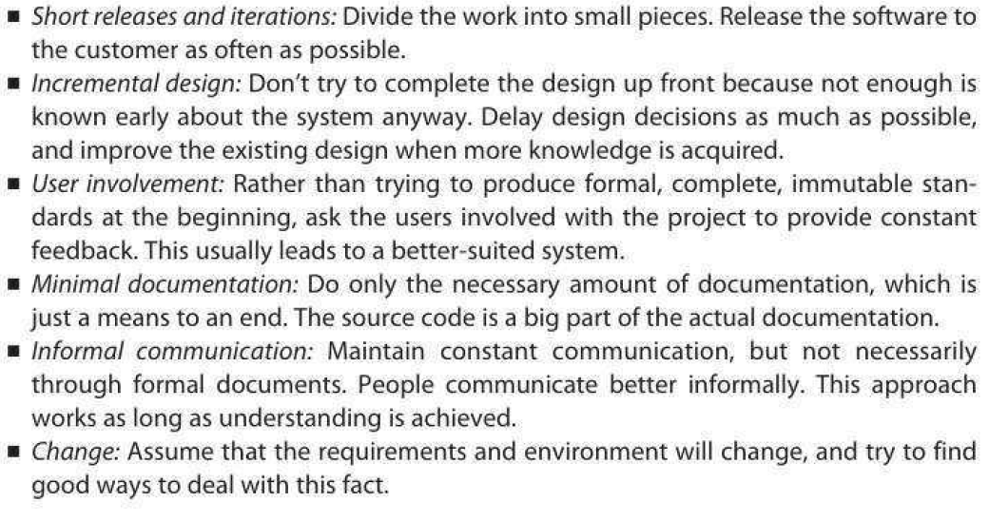
4. Giải thích các đặc trưng của các phương pháp/tiến trình Agile
5. Explain the main aspects that open source development shares with Agile methods
- Similarities
  - Small releases
  - Informal communications
  - Customer availability
  - Continuous integration
  - Shared Vision
5. Cho biết các khía cạnh mà phát triển nguồn mở chia sẻ với các phương pháp Agile.
7. Compare and contrast Agile and traditional methods
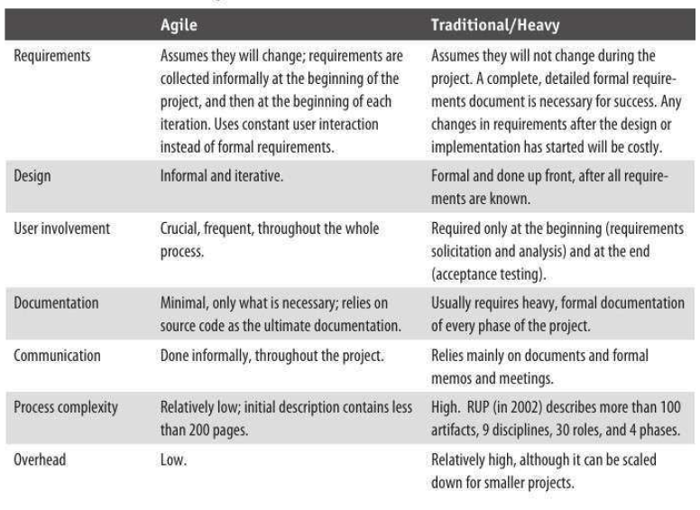
7. So sánh các phương pháp Agile với các phương pháp truyền thống.
Chapter 6. Requirements Engineering – Xây dựng các yêu cầu phần mềm
1. List and describe at a high level the steps involved in software requirements
engineering process
- Elicitation
- Documentation and definitions
- Specifications
- Prototyping
- Analysis
- Review and Validations
- Agreement and acceptance
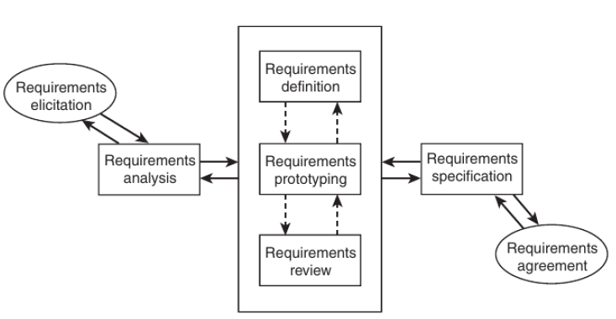
1. Liệt kê và mô tả các bước cơ bản trong quá trình xây dựng yêu cầu phần mềm.
2. What are the three main items that must be planned prior to conducting requirements engineering?
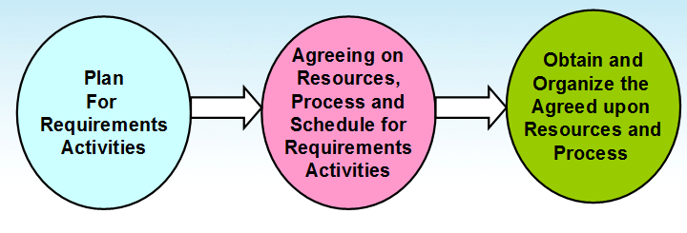
2.Cho biết ba công việc chính cần thực hiện trước khi xây dựng yêu cầu phần mềm.
3. What are the six main dimensions of requirements that you need to address when collecting requirements?
6-Dimensions of Detailed Requirements Elicitation
Requirements
Individual Functionality (1)
Business Workflow (2)
Data and Data formats (3)
User Interfaces (5)
Existing & Systems Interfaces (6)
Other Constraints: Performance,
Reliability, etc. (4)
3. Cho biết sáu chiều cơ bản của các yêu cầu phần mềm bạn cần giải quyết khi thu thập yêu cầu phần mềm.
4. List and “describe three items” that you will need to consider when prioritizing requirements.
- Current user/customer demands or needs
- Competition and current market condition
- Anticipated future and new customer needs
- Sales advantages
- Critical problems in existing product
4. Mô tả các mục bạn cần xem xét khi xác định mức độ ưu tiên của các yêu cầu.
5. What are the four types of requirements traceability?
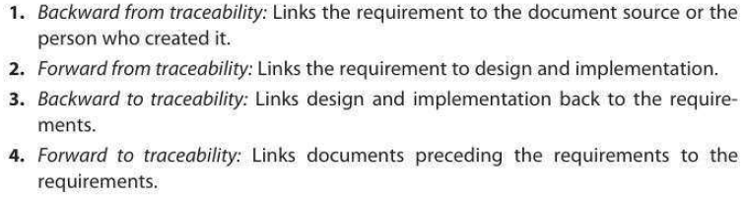
5. Cho biết 4 loại tạo vết của các yêu cầu.
Chapter 7. Design: Architecture and Methodology - Thiết kế
1. What is Software architecture? List key uses of architecture descriptions.
Software architecture:
- Definition: Software architecture is the structure or structures which comprise elements, their externally visible properties, and relationships among them
  - Elements: only interested in external properties needed for relationship specification
  - Details on how the properties are supported is not important for architecture
  - The definition does not say anything about whether an architecture is good or not – analysis needed for that
- An architecture describes the different structures of the system

Key Uses:
Understanding and communication
Reuse
Construction and evolution
Analysis
1. Kiến trúc phần mềm là gì? Bản mô tả kiến trúc có thể dùng vào việc gì?
2. What is the structure and characteristic of the architectural style: Pipe and filter. Give an example
- Well suited for systems that mainly do data transformations
- A system using this style uses a network of transforms to achieve the desired result
- Has one component type – filter
- Has one connector type – pipe
- A filter does some transformation and passes data to other filters through pipes
- A filter is independent; need not know the id of filters sending/receiving data
- Filters can be asynchronous and are producers or consumers of data
- A pipe is unidirectional channel which moves streams of data from one filter to another
- A pipe is a 2-way connector
- Filters have to perform buffering, and synchronization between filters
- Filters should work without knowing the identify of producers/consumers
- A pipe must connect the output port of one filter to input port of another
- Filters may have independent thread of control
2. Cho biết cấu trúc và các đặc điểm của kiểu kiến trúc đường ống và bộ lọc (Pipe and filter)
3. What is the structure and characteristic of the architectural style: Client-Server.
3. Cho biết cấu trúc và các đặc điểm của kiểu kiến trúc Khách-Chủ (Client-Server)

4. Cho biết cấu trúc và các đặc điểm của kiểu kiến trúc dữ liệu dùng chung (Share-Data)
4. What is the structure and characteristic of the architectural style: Shared-Data.

5. Cho biết cấu trúc và các đặc điểm của kiểu kiến trúc 3 tầng (Three tier)

5. What is the structure and characteristic of the architectural style: Three tier Style.
6. List and describe steps in database design.
- Conceptual modeling (done during analysis/requirement phase) produces ER diagram
- Logical design (to relational)
- Physical design (decide data types etc)
- Deployment/maintenance
  - Low-level physical (which hard-drive etc)
  - Adjustment of indexes
6. Liêt kê và mô tả các bước trong thiết kế cơ sở dữ liệu
7. Cho biết tên và mô tả ba loại biểu đồ UML trong phân tích và thiết kế hướng đối tượng.
7. List and describe 3 types of UML diagrams in OO Analysis and Design.
8. List issues with user interface design
- Most apparent to the user
- Two main issues
  - Flow of interactions
  - Look and feel
- Types of interfaces
  - Command-Line
  - Text menus
  - Graphical (GUI)
- Kinds of users
- Heuristics
- UI Guidelines
- Multicultural issues
- Metaphors
- Multiplatform software
- Accessibility
- Multimedia Interfaces

8. Cho biết các vấn đề trong thiết kế giao diện người dùng
Chapter 8. Design Characteristics and Metrics – Các đặc trưng và độ đo thiết kế
1. Mô tả hai đặc trưng cơ bản của một bản thiết kế tốt.
1. Describe two fundamental characteristics of a good design besides the design should match requirements.
- Besides the obvious - - - design should match the requirements - - - there are two fundamental characteristics:
  - Consistency across design:
    - Common UI
      - looks
      - Logical flow
    - Common error processing
    - Common reports
    - Common system interfaces
    - Common help
    - All design carried to the same depth level
  - Completeness of the design
    - All requirements are accounted for
    - All parts of the design are carried to their completion, to the same depth level
2. Describe Halstead Volume metric.
2. Trình bày cách tính độ đo dung lượng (Volume metric) của Halstread để phân tích độ phức tạp của chương trình nguồn.
3. Trình bày cách tính độ phức tạp module Cyclomatic (Cyclomatic Complexity) của McCabe.
4. Trình bày cách tính độ phức tạp liên module của Henry-Kafura.
5. Trình bày các cấp độ ghép nối (coupling) giữa các module.
6. Trình bày các cấp độ kết dính (cohension) giữa các phần tử trong một module.
7. Trình bày cách tính độ đo kết dính chức năng yếu và mạnh (weak functional cohesion and strong functional cohesion) của Bieman và Ott
8. Trình bày 8 quy tắc thiết kế giao diện người dùng của Shneiderman và Plaisant.
Chapter 9. Implementation – Xây dựng chương trình
1. Cho biết các lỗi lập trình thường gặp
- Memory Leaks
  - Memory that is not freed when no longer needed
- Freeing an already freed resource
- NULL dereferencing
  - Trying to access the contents of a location that points to NULL
- Lack of unique addresses
  - Caused by aliasing
- Array index out of bound
- Arithmetic exceptions
- Off by one
  - Starting at 1 when we should start at 0
- Enumerated data types
  - Cause overflow and underflow
- Illegal use of & instead of &&
- String handling errors
- Buffer overflow
2. Liệt kê 10 thông lệ lập trình (programming practices)
- Control constructs: Use only a few structured constructs (rather than using a large number of constructs)
- Goto: Use them sparingly, and only when the alternatives are worse
- Information hiding: Use information hiding
- Use-defined types: use these to make the programs easier to read
- Nesting: Avoid heavy nesting of if-then-else
  - Easier to do if conditions are disjoint
- Module size: Should not be too large – generally means low cohesion
- Module interface: make it simple
- Robustness: Handle exceptional situations
- Side effects: Avoid them, document when exist
  - Use of global variables, etc.
- Switch case with default
- Empty catch block: always have some default action rather than empty
- Empty if, while: bad practice
- Read return: should be checked for robustness
- Return from finally: should not return from finally
- Correlated parameters: Should check for compatibility
  - Parameter needs to match the operation

3. Liệt kê các chuẩn lập trình Java
4. Vẽ và mô tả biểu đồ biểu diễn tiến trình lập trình tăng dần (incremental coding process)
5. Vẽ và mô tả biểu đồ biểu diễn tiến trình lập trình hướng kiểm thử (test driven development)
6. Trình bày các đặc điểm của lập trình đôi (Pair Programming).
7. Liệt kê 10 mục cần kiểm tra khi thanh tra chương trình
Chapter 10. Testing - Kiểm thử
1. Cho biết bốn kỹ thuật phát hiện lỗi phần mềm.
- Testing
- Inspections and Reviews
- Formal methods
- Static analysis
2. Cho biết các lớp kỹ thuật kiểm thử phần mềm.
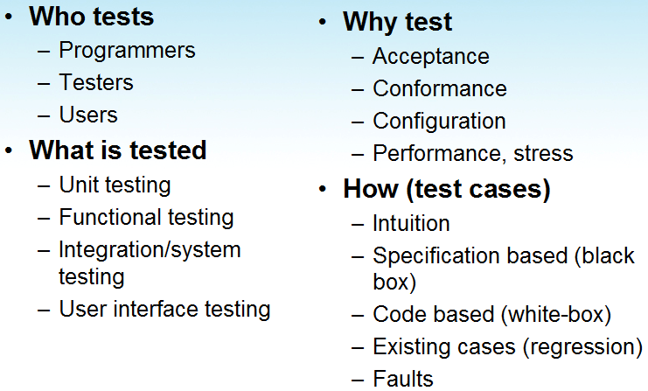
3. Cho biết 4 cấp độ kiểm thử phần mềm.
User needs
Acceptance testing
Requirement
specification
System testing
Design
code
Integration testing
Unit testing
4. Trình bày kỹ thuật kiểm thử phần mềm phân lớp tương đương (Equivalence Class Partitioning)
5. Trình bày kỹ thuật kiểm thử phần mềm phân tích giá trị biên (Boundary Value Analysis)
6. Trình bày kỹ thuật kiểm thử phần mềm phân tích đường dẫn (Path Analysis)
Chapter 11. Configuation Management, Integration, and Builds - Quản lý cấu hình, tích hợp và xây dựng chương trình chạy
1. Liệt kê 10 sản phẩm (artifacts) được quản lý cấu hình.
2. Cho biết vai trò của quản lý cấu hình và các chức năng cơ bản của quản lý cấu hình.
3. Cho biết mô hình lưu trữ và truy cập các thành phần (Parts Storage and Access Model) trong quản lý cấu hình và các tính năng chính của mô hình này.
Chapter 12. Software Support and Maintenance - Hỗ trợ và bảo trì phần mềm
1. Cho biết các công việc cần thực hiện trong hỗ trợ khắc phục khiếm khuyết phần mềm (defect support) và cho biết xu hướng thay đổi của số lượng khiếm khuyết theo thời gian sau khi chuyển giao phần mềm.
2. Trình bày hai đặc điểm của công việc hỗ trợ khách hàng (Customer Support)
- Software support is not free
  - Most charge an annual fee (e.g. 18% of product)
- Software support is not forever
  - Most product goes through a number of releases
  - Each product release is only supported for a limited number of years
  - Customers/users are moved from back-level software to the current release as soon as possible
    - Usually support no more than 2 back-levels of a software
3. Cho biết các công việc thực hiện trong giai đoạn trước khi kết thúc việc hỗ trợ phần mềm, hay còn gọi là giai đoạn mặt trời lặn (product sunset period).
4. Trình bày các mục cần có trong một mẫu yêu cầu thay đổi trong giai đoạn bảo trì phần mềm.
Chapter 13. Software Project Management – Quản lý dự án phần mềm
1. Cho biết các giai đoạn và các mục tiêu của tiến trình quản lý dự án phần mềm.
2. Cho biết các bước của giai đoạn lập kế hoạch trong tiến trình quản lý dự án phần mềm.
3. Cho biết các công việc được thực hiện trong giai đoạn tổ chức trong tiến trình quản lý dự án phần mềm.
4. Trình bày chương trình khung để xây dựng cấu trúc phân rã công việc (Work breakdown Structure) trong việc ước lượng công sức hoàn thành dữ án.

